Cook book

**Introduction**

* + Project Title: cook book
  + Project ID: SWTID1741243634154012
  + Team Leader: MEER ARSHAD AHAMED I
  + Team Member: YUVARAJ S
  + Team Member: HARISH V
  + Team Member: SHAKEER BASHA S
  + Team Member: RAZIKFAREED M

**Project Overview**

**Purpose:** Recipe discovery platform designed to help users find, explore, and cook delicious meals. It provides a collection of diverse recipes categorized by cuisine, dietary preference, meal type, and occasion. Users can browse, search, and filter recipes based on their tastes and needs.

**Features:**

* Discover New Recipes – Users can explore a wide variety of recipes for different occasions and preferences.
* User-Friendly Search & Navigation – A clean UI with search functionality to help users find recipes quickly.
* Step-by-Step Instructions – Detailed cooking instructions and ingredient lists for easy meal preparation.
* High-Quality Food Imagery – Visually appealing images to inspire and help users choose recipes.
* Personalized Experience (Optional) – Users may save favorite recipes , create meal plans, and get recommendations based on preferences.
* **Community & Sharing (Optional) – Users can upload their own recipes, share reviews, and exchange cooking tips.**

**Architecture**

**Component Structure:**

* + - App.js - The root component, likely handling routing and rendering major components.
    - Navbar.jsx - Manages the navigation bar
    - Hero.jsx - Likely handles the hero section (main banner).
    - Newsletter.jsx - Manages newsletter subscription.
    - Category.jsx - Likely used for displaying recipe categories.
    - Home.jsx - The main homepage.
    - Recipe.jsx - Displays a recipe or list of recipes

**State Management:**

* Uses React's useState and useEffect hooks for local state management
* Data fetched and managed using axios
* useContext for global state (optional for future expansion)

**Routing:**

* Utilizes react-router-dom
* Routes include:
  + - * / - App.js
      * / package.json
      * /Recipe.jsx

**Setup Instructions**

**Prerequistes:**

* + - Install [Node.js](https://nodejs.org/en/download/)
    - Install Git for version control ([Git Download](https://git-scm.com/downloads))
    - IDE: [VS Code](https://code.visualstudio.com/download)

**Installation:**

* git clone [repository_url]
* cd Recipies-app
* npm install

**Start the application:**

* cd path/to/your/recipe-app
* npm install
* npm start
* npm run start

**Folder Structure**

recipe-app/

│── src/ # Main source code

│ │── components/ # Reusable UI components

│ │ │── Navbar.jsx

│ │ │── Hero.jsx

│ │ │── Newsletter.jsx

│ │ │── Footer.jsx

│ │── pages/ # Main pages

│ │ │── Home.jsx

│ │ │── Category.jsx

│ │ │── Recipe.jsx

│ │── images/ # Images for UI (hero, banners, etc.)

│ │ │── hero-img1.png

│ │ │── hero-img2.png

│ │── styles/ # CSS stylesheets

│ │ │── App.css

│ │── hooks/ # Custom React hooks (if any)

│ │── context/ # Context API for state management (if needed)

│ │── App.js # Root component, handles routing

│ │── index.js # Entry point of the app

│── public/ # Static files

│ │── favicon.ico

│ │── index.html

│ │── manifest.json

│ │── robots.txt

│── package.json # Dependencies & scripts

│── README.md # Project documentation

**Running the Application**

* **Frontend:** npm run dev

**Component Documentation**

**Key Components:**

* + - index.js : The main entry point of the React app.
    - App.js → Handles routing between different pages.
    - pages/Home.js → Displays featured categories and recent recipes.
    - pages/Recipes.js → Fetches and displays a list of recipes.

**Reusable Components:**

* *SearchBar.js:* Search input for filtering recipies.
* components/RecipeCard.js → Displays a summary of each recipe.
* *pages/RecipeDetail.js → Displays a single recipe's details.*

**State Management**

* **Global State:** Not yet implemented (potentially using Context API)
* **Local State:** Managed with useState and API calls with axios

**User Interface**

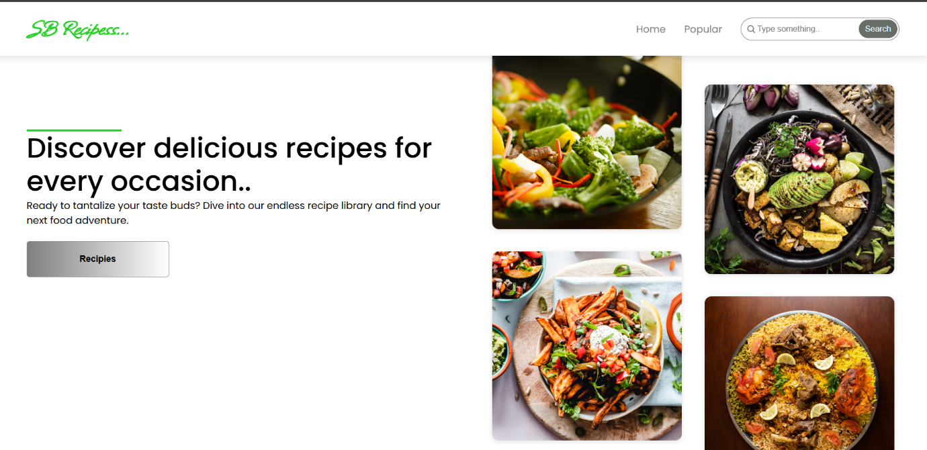

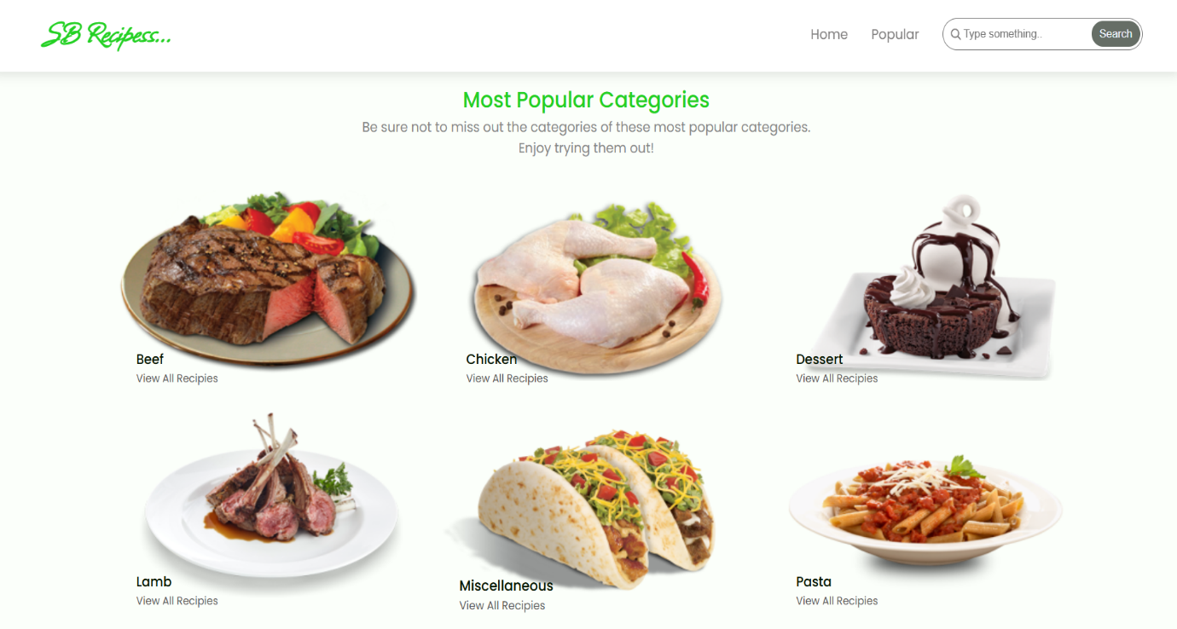

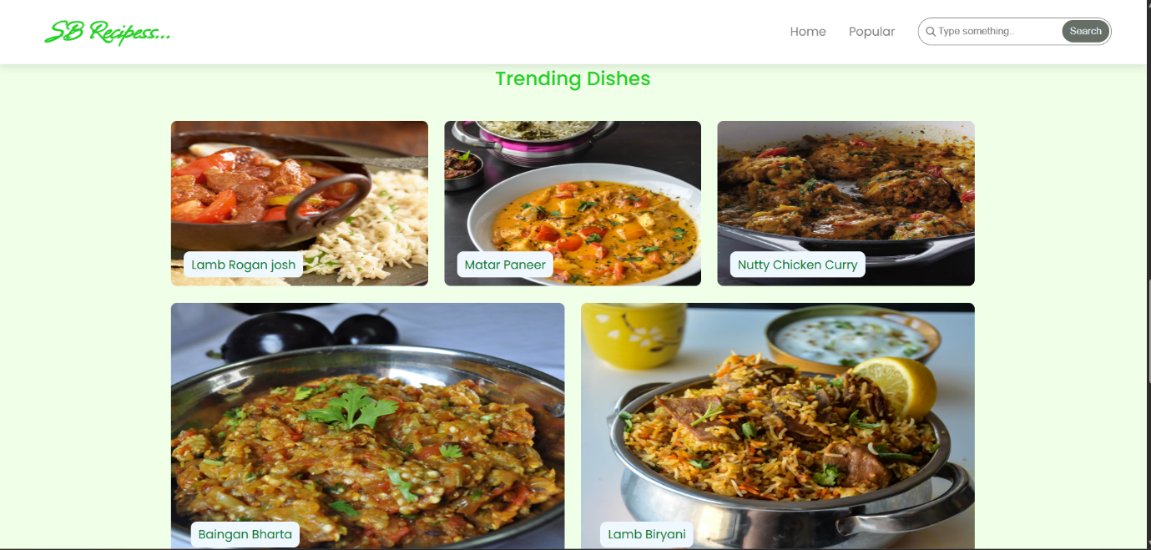

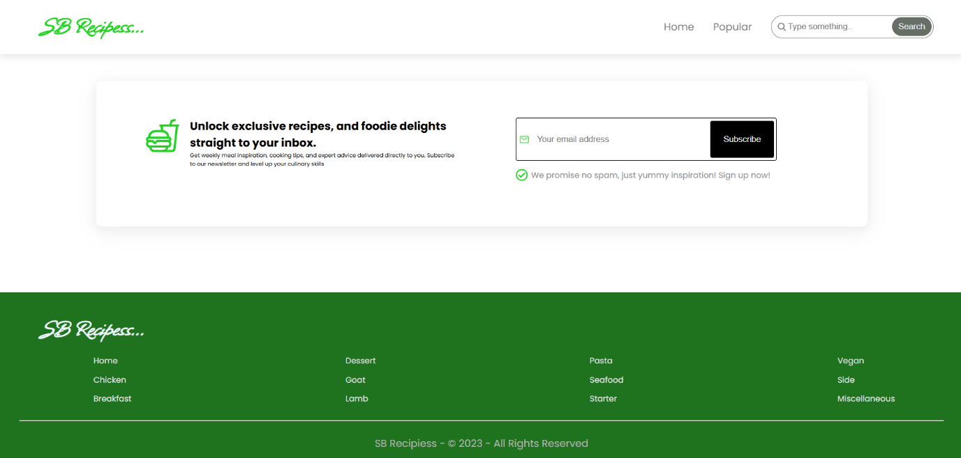

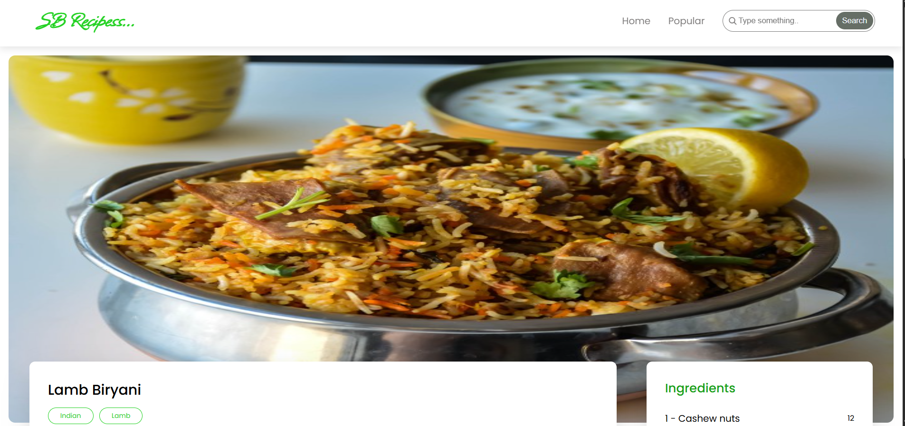

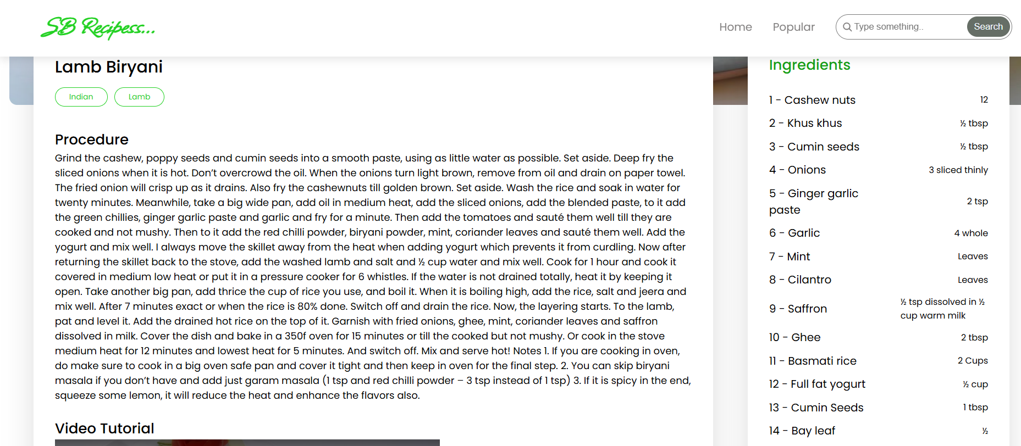

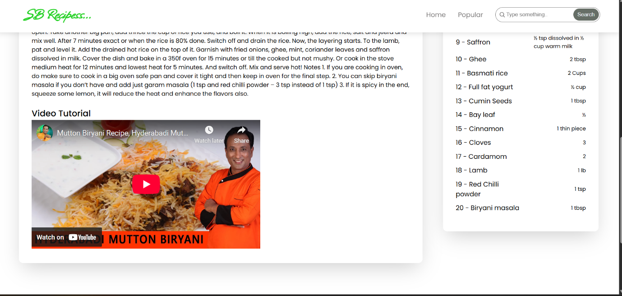

**Styling**

**CSS Frameworks/Libraries:**

* + - Bootstrap/Tailwind CSS
    - Custom CSS for additional styling

**Testing**

**Testing Strategy:**

* Unit tests with Jest & React Testing Library (future enhancement)

**Code Coverage:**

* No test coverage tool implemented yet

**Demo:**

https://drive.google.com/drive/folders/1K7fv6X67zYMZHIpei6BQrit19l55XRZW?usp=sharing

**Known Issues**

* Some images or videos might not load properly due to CORS restrictions.
* Limited offline access to recipes.

**Future Enhancements**

* Implement user authentication for personalized recipe collections.
* Improve UI with smooth animations and transitions.
* Integrate a real-time API for fetching new recipes dynamically.
* Add a meal planner feature for users to schedule meals.
* Enable offline support for saved recipes.
* Improve search and filtering for better user experience.
* Allow users to submit their own recipes and rate others.